TEAM 11

Computer Vision Section:

System in-depth:

Features:

Libraries used:

Design considerations:

Other relevant information:

Micro-controllers Section:

Features:

* Home Protection: When the house is **locked**, the PIR Sensor scans for motion and if detected, the ATmega sends a warning message to the Control Interface.
* Dynamic Lighting: When the light level of the surrounding is low, the Photo-resistor detects the low light and the ATmega lights up an LED and vice versa.
* Dynamic Fan Speed/RGB Indicator: According to the following ranges of temperature picked up by the NTC Thermo Sensor, the RGB – Fan Speed are as follow:

∗T > 30◦C : Red – 3500 RPM

∗ 30◦C => T => 20◦C: Green – [3000, 2000] RPM

∗ T < 20◦C: Blue – Fan Off

* Entering/Exiting House: A person can enter the house by:

1- Entering the correct password on a 4*4 keypad

2- By scanning their face (if a person is in the database, the Control Interface sends an **open** command to the ATmega)

3- Pressing **open** on the Control Interface.

A person can also **lock** the house via the Control Interface, turning off all the lighting and fan, and enabling the PIR Sensor to sends warning upon motion detection. The house/system is unlocked if the door is opened by any means of the 3.

* Door Password: A person can enter the house using a password and can change the password via the Control Interface. The password can have a length up to 31 characters. If a wrong password is entered, a Buzz is played and a warning message is sent to the Control Interface.

Libraries used:

* <Keypad.h>: For the keypad

Design considerations:

* If the door is opened, that means: the servo motor rotates up to a certain degree, waits for about 7 seconds and then closes.
* Added a “lock” feature, explained in the previous section.
* The fans always spin in 1 direction, therefore, the direction (in1 and in2) pins of the driver are connected directly to 5V and GND instead of the ATmega.

Other relevant information:

* The ATmega chip is programmed for the first time using an Arduino as ISP Programmer to burn the bootloader and/or upload the code.
* A USB to TTL (Serial) was used for the communication between the ATmega and the Control Interface (Computer), can also be used for uploading code after burning a bootloader first.

Hardware Section:

Altium:

Schematic:

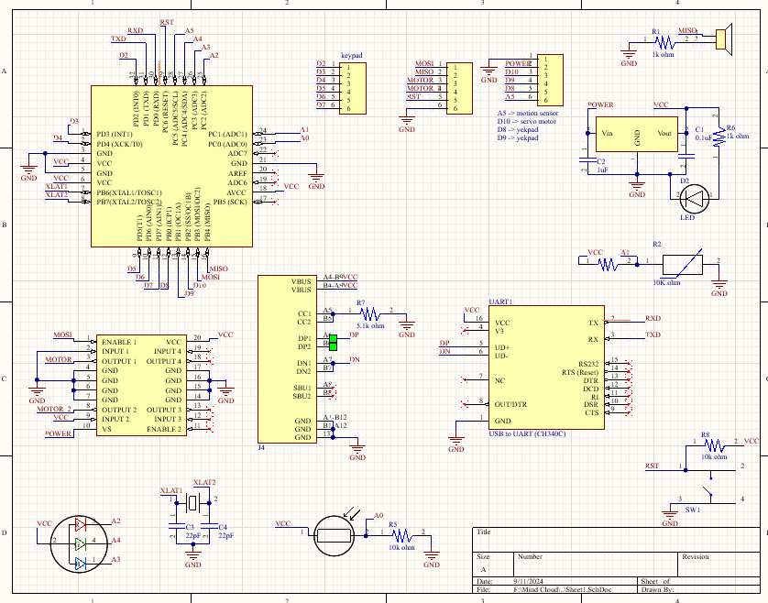

PCB-Top:

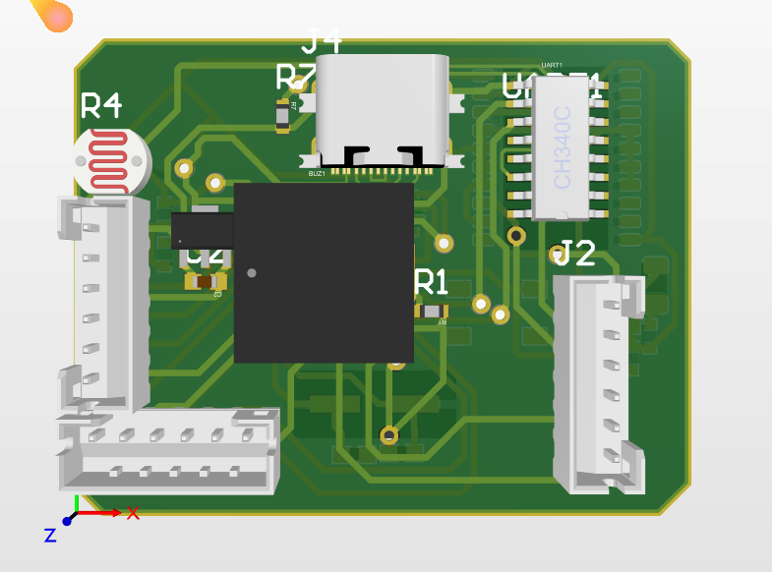

PCB-Bottom:

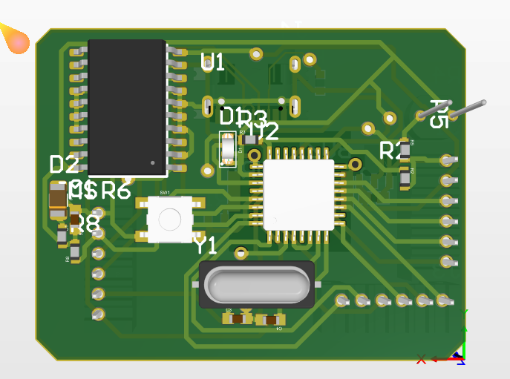

PCB-Traces:

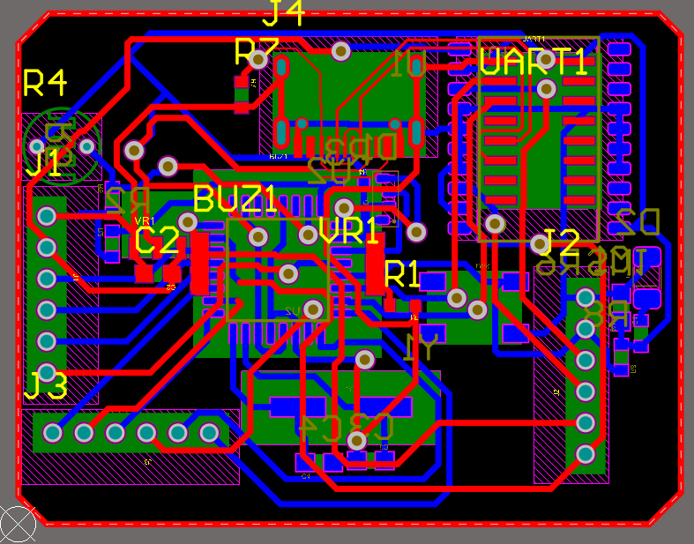

Design considerations:

* The servo motor, the fans motor and the keypad are not included in the Altium design, instead, they have pin-headers to connect them to the board externally.
* There are 6 Pins needed to exist as pin-headers to be able to program the ATmega chip (Burn the bootloader). The 6 pins are (MOSI – MISO – SCK – VCC – GND – Reset).
* We’re using a USB-to-UART chip and USB-C port for the communication of the ATmega and Computer.

Links:

[AmirKaseb/Mini-Smart-Home-System: This Repo demonstrates our journey ( Team 11 ) for Mind Cloud Final Project (github.com)](https://github.com/AmirKaseb/Mini-Smart-Home-System/tree/main)

https://www.tinkercad.com/things/emIDLEaHkLq-mindcloud-megaproject-microcontroller-team-11